CSCE 310

Homework 6

Database Systems

Raymond Zhu

923008555

1.

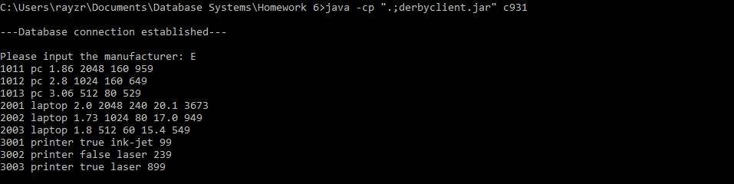

2.

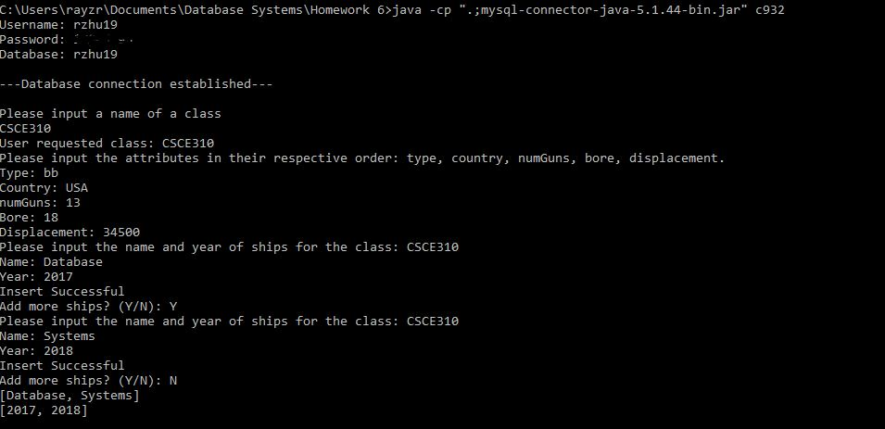

3.



4.

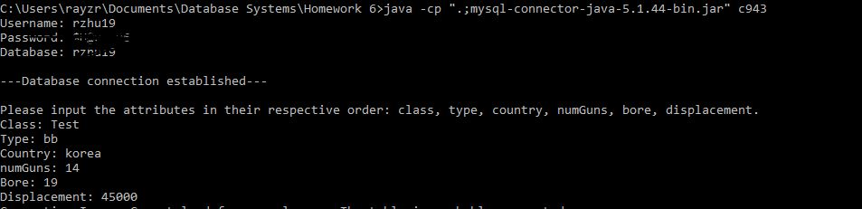

An aggie does not lie, cheat, steal, or tolerate those who do